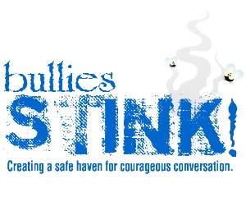

Bullies Stink wants you!
We are currently seeking participants of color to participate in a documentary entitled, “Our Bullying Project.” The goal of this project is to highlight the bullying stories of people of color. Together we can expand the scope of bullying services throughout the country. To participate please contact email Carolyn@bulliesstink.com. We look forward to hearing your story!

